BrainPop Lunch and Learn February 10, 2020
Log in with Clever (Non-classroom teachers MIGHT need to go through BrainPop.com – use FHSD email as username and then “Forgot Password” so you can retrieve or reset PW.)

BrainPop
- BrainPop is not just videos anymore. Students have options to create their own movie or use coding to show what they’ve learned. Plus, BrainPop has integrated more resources to supplement learning--they have primary and secondary resources included.
- Watch the FHSD Webinar: (Code to join: bpFHSD1.06.20)
- Learn about BrainPop resources with the BrainPop 101 course.
- All teachers and LMS (K-8) have access to BrainPop and BrainPop Jr, as well as all of the resources that go along with BrainPop.
Dashboard > Classes/Assignments/Projects
Quiz Mixer
BrainPop 101 – Introductory Course for Teachers
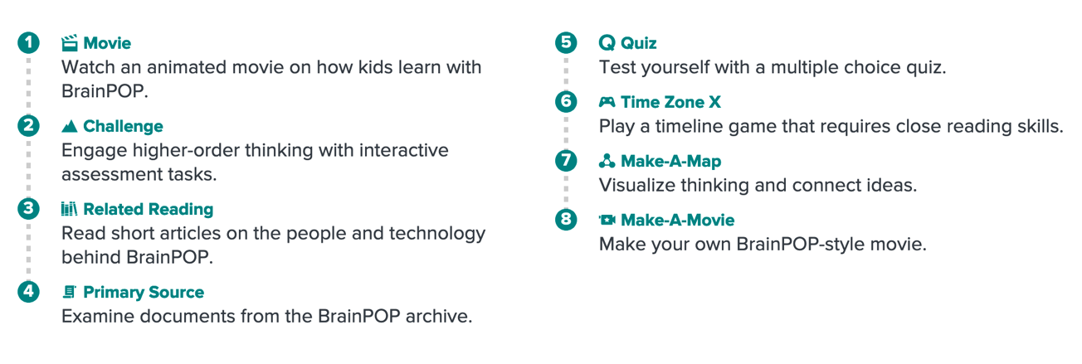
Creative Coding
https://educators.brainpop.com/tools-on-brainpop/creative-coding-teaching-resources/
https://www.brainpop.com/creative-coding/sample-projects/
Make a Movie
auto-saves for later editing; time limit 10 minutes; 20 scenes; 30 seconds of audio
Educator Videos/Screencasts
https://educators.brainpop.com/video/

